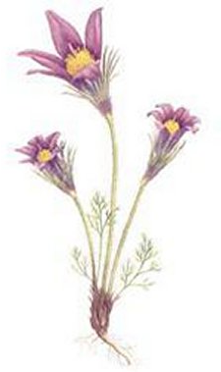
Plant Project Outline & Guide
- Purpose – Learn about common plant species of our area, while learning and applying collecting methods, observations, photography, and data collecting to complete a long term project.
- Important Dates
  - 2nd Wednesday in October
  - Labs not completed by the due date will be reduced 10% for every class period not turned in.
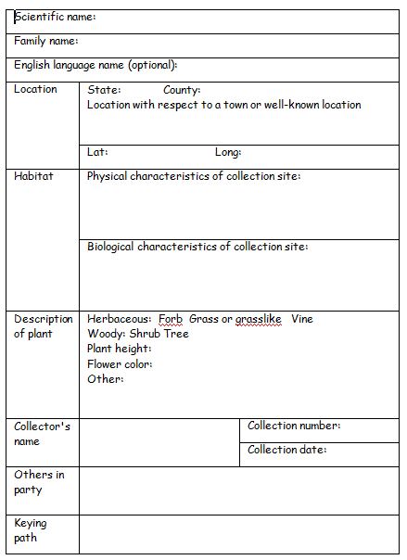
- Requirements
  - Each plant must be attached to sheet of stock paper. With hot glue or some other adhesive approved by your instructor.
  - On the front you must fill out the label shown and it needs to be placed on the front of each plant sheet.
  - On the back you should have label including:
    - Species Common and Scientific name
    - Collection date
    - Collector
- Identification:
  - Use plant identification books or internet.
  - Weeds of the Great Plains.
  - You can also ask individuals like farmers or others that might know common names, but make sure to check information.
- Data collection
  - Each of following data must be collected and placed somewhere in your field notebook.
    - Species common name and scientific name
    - Description of habitat found and plant
    - Location (GPS & Closest town, County,& State)
    - Drawing (simple drawing)
    - Reference Identification (Used to identify plant.)
- Collecting
  - Make plans and timeline of how you are going to complete the lab. Start early that way you are not rushed with a deadline.
  - Pay attention to in class demonstrations on how to collect and mount plants on boards.
  - Know where all materials are located to complete the lab in a timely manner.
  - Don’t wait till it starts to freeze.
  - There is a lot to do in this lab. Collecting the plants is just one small part.
- Scoring
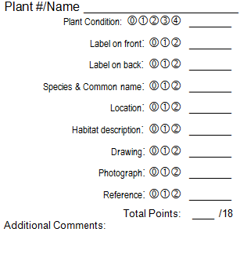
  - Total points 216 points
  - 12 plants must be collected. Each plant can score up to 18 points.
  - On the right is diagram showing the scoring rubric that is used for each of the 12 plants.
  - Points can be earned with each plant that contain each of following
    - Plant (4 Excellent/Good/Fair/Poor)
    - Label on front (2 Complete/Incomplete)
    - Label on back (2 Complete/Incomplete)
    - Species common & scientific names (2 Complete/Incomplete)
    - Location (2 Complete/Incomplete)
    - Habitat description (2 Complete/Incomplete)
    - Drawings (2 Complete/Incomplete)
    - Photographs(2 Complete/Incomplete)
    - Reference (2 Complete/Incomplete)
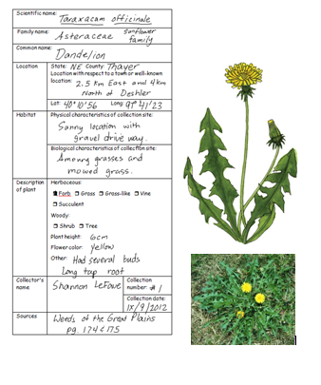
- Collection Example:
Poster board Front

  - Here is an example of back and front of completed plant.
  - Notes:
    - Scientific names should always be underlined.
    - Front should include all the things shown here.
    - Month should always go first in roman numeral, date, and then year.
    - It should be in your best penmanship and in pen. You can also type label see your instructor for template.
    - Always use metric system.

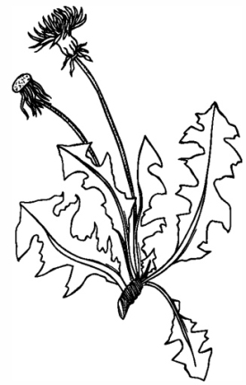
Field Notebook
Taraxacum officinale “Dandelion” #1
Gravel driveway along mowed grass yard
Plant was low on the ground with flower stems being long and upright.
Thayer County, NE (40° 10’56 N 97°41’23 W)
IX/9/2012

Poster Board Back
Taraxacum officinale “Dandelion”
IX/9/2012
Shannon LeFave

Back

