Spay & Neuter Lab Activity Anatomy & Physiology
Pre-lab Activities: Total Points: 80
- Define:
  - Spay -
  - Neuter –
- What is the age that a dog or cat can be spayed?
- What are some preparations that must be made before your cat can be spayed or neutered?
- Watch the spay video found at youtube; https://www.youtube.com/watch?v=uVSN2EJFEJw Write down some things that you observed.

- Watch the neuter video found at youtube; https://www.youtube.com/watch?v=Lh8hhG-rY2Q Write down some things that you observed.

- Draw and label the reproductive structures of the female cat.
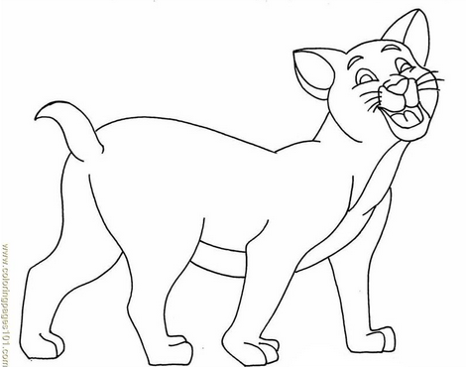

- Draw and label the reproductive structures of the male cat.
- Make sure to read the following sections so that you are prepared with questions and observant during the activity.
Lab Activities: Observe the following and then write them down after the procedures.
- How long did each procedure last?

- What are some of the preparations that were done before the start of the spay and neuter?

- Describe some things that took place.

- What are some of the tools used during the procedures?

Post-lab Activities: Complete after the procedures. Attach another sheet of paper to complete. Use complete sentences.
- What are some the things that you learned?
- What are some things that differed from the pre-lab videos verse what actually took place.
- Why do spay and neuters?
- Explain how these might be different in cats vs dogs? Canines vs equine? Canine vs bovine?

